To CSV and From CSV module capabilities.

When dealing with large channel count systems some time sit would be nice to be able to export the current channels to excel and use all the futures of excel to modify and edit the large list of channels and then import them back into the module. This is possible with DCAF Core 1.3.0.12 which provides additional overrides had been added to the modules to allow to add the to CSV from CSV function to the module.

# Configuration Class

The configuration class has 2 new overrides that need to be updated, and a recommended unit test:

## To String Array

This override is similar to “To Table”, but in the configuration class and might include fields that will not be displayed in the configuration editor. It allows to export all the properties of a line that can the user should be able to edit. For new modules you can use this VI inside of the To table of the configuration class.

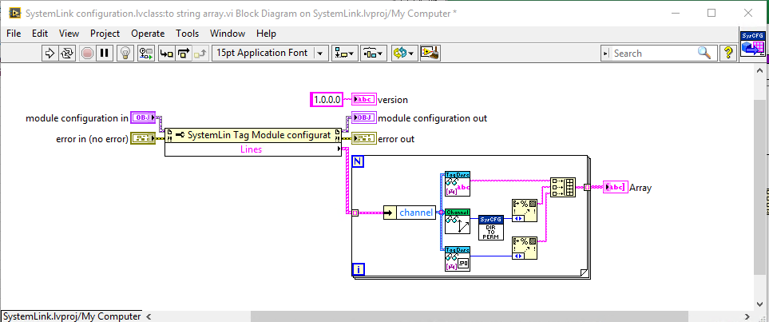

## From String Array

This VI generates lines from array of strings. This VI should have defaults for the values that are not configured. In general, its recommended that it replaces all the existing lines with the new lines.

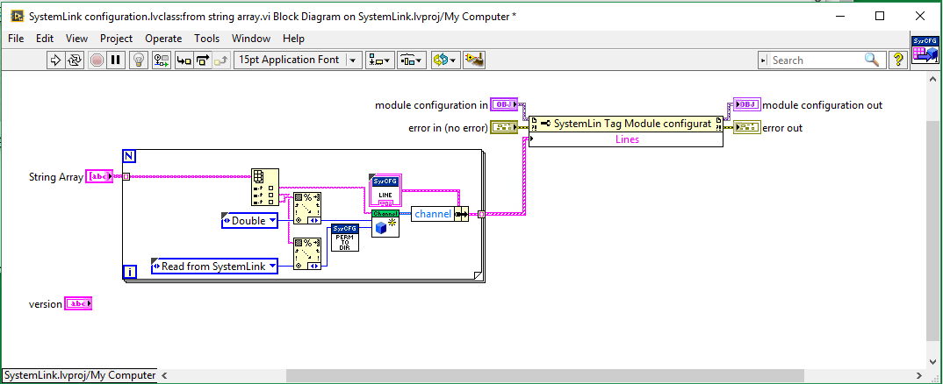

## To and From String Array Test

It is also recommended to add a New Unit test to verify this 2 new Vis are working as expected.

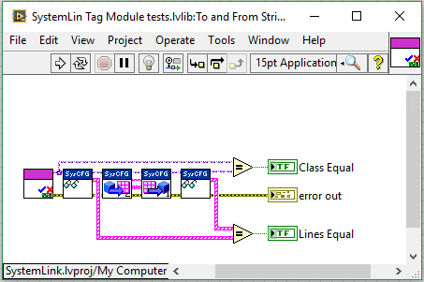

Note The Version Terminal is added in case it is required by some specific use case, but in the general of just use the import and export to edit, the version number can be ignored.

# Editor Node:

The editor node class has 2 new overrides, you need to update the UI to allow accessing the new methods and there is a new unit test recommended.